Prepared By: K. Jones

Prepared For: Cylistic Bike Share

December 31, 2022

Divvy Bike Share

Google Capstone Project

TABLE OF CONTENTS

INTRODUCTION

1. Statement of the Problem
2. Significance of the study
3. Deliverables
4. Scope of the Study

METHODS OF ANALYSIS

1. Sources of Data and Safety
2. Licenses
3. Cleaning and Manipulation

DATA FINDINGS AND CONCLUSIONS

1. Summary of Analysis
2. Supporting Visualizations and Key Findings
3. Recommendations

**INTRODUCTION**

In effort to secure longevity in the fast-paced app market of today, it is crucial to understand the habits and needs of potential members. In the past, local transportation relied solely on cab, bus and train services that relied on space capacity and operation schedules to steer annual projections, the current market can use real-time data to personalize services with the privilege of classic and electric bikes offering a more intimate relationship in a service-based market allowing for more accurate projections in shorter timeframes.

Ensuring sustainability in the future in a ever-growing market, Cyclistic , wants to understand the “why” and “how” of it’s casual riders and their differences to membership holders.

1. **Statement of the Problem**

How do annual members and casual riders use Cyclistic bikes differently?

**Objective:**

Maximize the number of annual memberships.

1. **Significance of the Study**

Understanding the difference between members and casual riders will lead marketing strategies to increases annual membership by converting casual riders to members.

1. **Deliverables**

Design marketing strategies aimed at converting casual riders into annual members.

**Understand how annual members and casual riders differ.**

Why would casual riders buy a membership?

How digital media could affect their marketing tactics.

Analyze Cyclistic historical bike trip data to identify trends.

1. **Scope of Study**

The study is limited to users of the Divvy Bike share only. For the purposes of this study, casual rider shall be defined as riders who do not participate in the annual membership program. Also, total ride times will be determined by the column of the rider’s status.

**METHODS OF ANALYSIS**

1. **Source of Date and Storage**

The date used in this analysis is collected in real time from Cylistic’s records of Divvy trips or rentals. The records are both quarterly and monthly. Each record should contain geographical information, rider status, dates, bike type, ride times and bike Id. It should be noted that all records are not complete, and some locations are either no longer in existence or new in development. Personal identifying information about each rider is not recorded in the datasets.

Cyclistic historical trip data:

<https://divvy-tripdata.s3.amazonaws.com/index.html>

* October 2021
* December 2021
* April 2022
* July 2022

Datasets were:

* + downloaded locally
  + converted as Excel files
  + uploaded into SQL and saved into a single data frame
  + Collection of data frame saved as XML file and stored locally.

1. **Licenses**

Open license:

Motivational International Inc:

<https://ride.divvybikes.com/data-license-agreement>

1. **Cleaning and Manipulation**

**Cleaning:**

* Check for null values and exclude them from the table. Null values will cause errors in queries, null values shown for popular ride day excluded from results.

* Rentals less than 1 minute in length were removed as test rides or rider error and rides greater than 300 minutes due to possible docking errors.

* Ride type queries do not include rides less than 5 mins to focus on riders who ride for a longer time based on the bike chosen. Possibly identifying classic riders who ride for exercise in comparison to electric riders who ride for social scenery or physical assistance.

**Manipulation:**

* Prepare date and time to create accurate start and end time columns for each month representing an assigned season- October = Fall, December = Winter, April = Spring, July = Summer. *October is the only month needing an update.

* Create a temp table with columns needed for queries based on ride types, status, start and end date, start and end time.

* Add a column that calculates the total ride time in minutes.

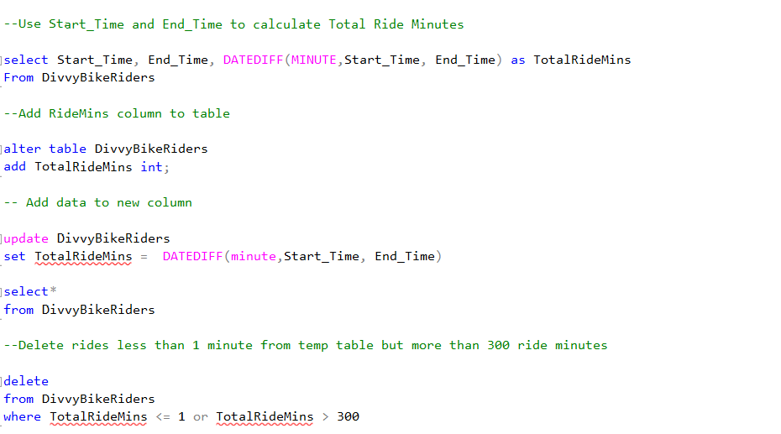

* Separate date into 3 separate columns.

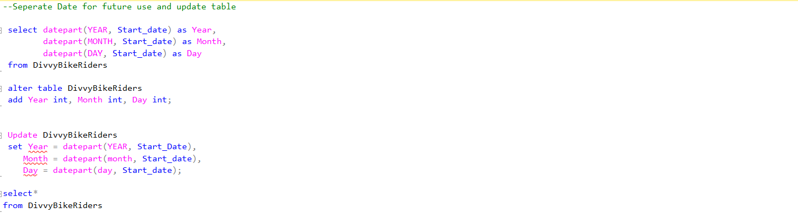

* Update day and month from int to char.

* Add a column to reflect seasonal use.

**DATA FINDINGS AND CONCLUSIONS**

* 1. **Summary of analysis:**

Casual riders:

* Ride less often than members.
* Ride for a longer time than members.
* Ride more in the warmer months.
* Prefer electric bikes over classic
* Do not dock bikes properly or as consistently as members.
* Popular ride day varies by season. Most popular at the beginning of the week during summer months.

Data table cleaned with new columns:

* 1. **Supporting visualizations and key findings**

Casual riders ride more in during summer and autumn seasons, dropping below 100,000 riders during the month December (which is significant giving that December is not the coldest month during the Chicago winter season <https://freetoursbyfoot.com/weather-in-chicago-in-january/#:~:text=HOW%20COLD%20IS%20CHICAGO%20IN,F%20(%2D9%C2%B0C).> ). While members maintain over 230,000 riders over the course of three seasons/months autumn, spring and summer. Close to 50% of casual riders ride during the summer months as seen in the table below.

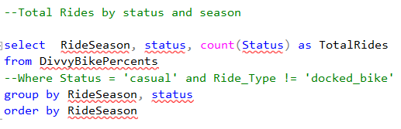

While members ride more often than casual riders, casual riders on average ride close to 50% longer than members. Meaning that they ride more minutes per rental. The chart below shows the average of both sets of riders. This even extends through the winter months.

Looking at what days are more poplar for casual riders by season/month, the chart below displays that casual riders and members vary on not only seasonal usage, but also choice of day to ride, concluding that the purpose of the rental may vary by status. Casual riders tend to ride more on Mondays and Tuesdays possible due to tourist activity.

In the four charts below, it is noted that total ride minutes are consistent with the number of rides where as total ride minute account for the majority of casual riders July/Summer usage times for both classic and electric bikes, almost matching that of members and beating out member riders for electric bike usage in July. Providing more support for the argument that the boost in casual riders in the warmer month may be more in alignment with the high tourist and event season.

* 1. **Recommendations**
* Appeal to casual members during spring season highlighting summer membership benefits. With summer memberships beginning in mid-April.
* Consider seasonal packages. Include a seasonal analysis as part of package that shows potential savings based on current members testimonies on savings
* Include incentives when purchasing a membership during popular summer events such as Water Flicks, Taste of Chicago, Chinatown Summer Fair and Lollapalooza. For instance, casual riders can earn additional points or a discounted rate for becoming a member during the selected events dates.